**JobPortal –revision two**

CA2 open source technology

B teja 11713846

RKE011B67

Submitted to Ms.isha

Job portal website is designed by PHP and mysql database.

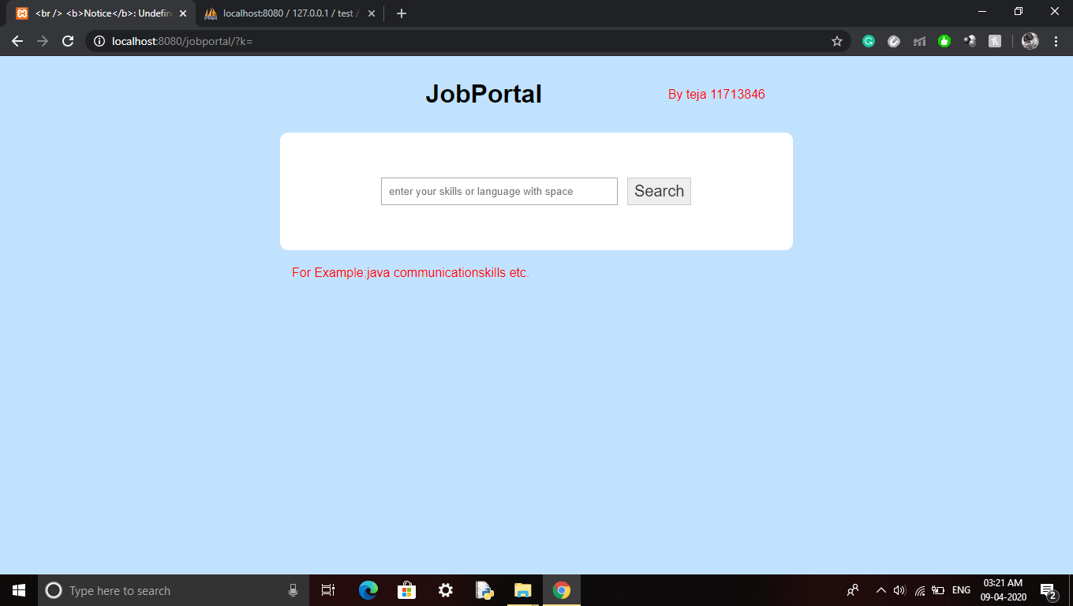

First page with a search engine .

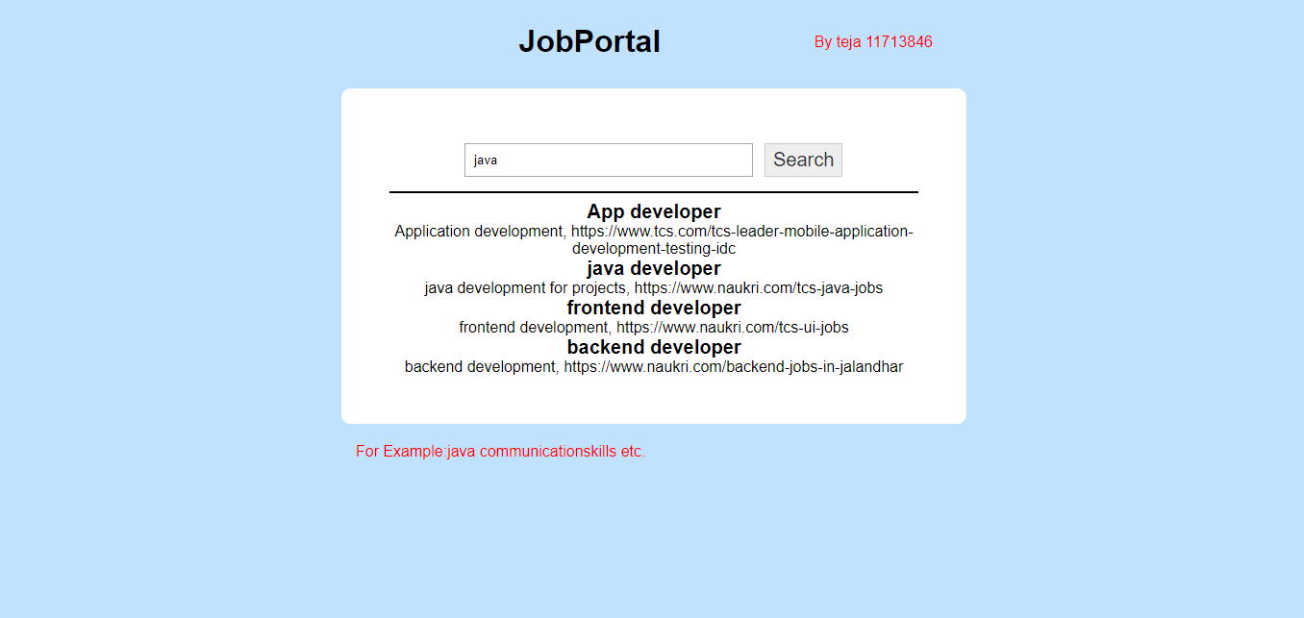

This screenshot is having a output of skill = java in the search engine

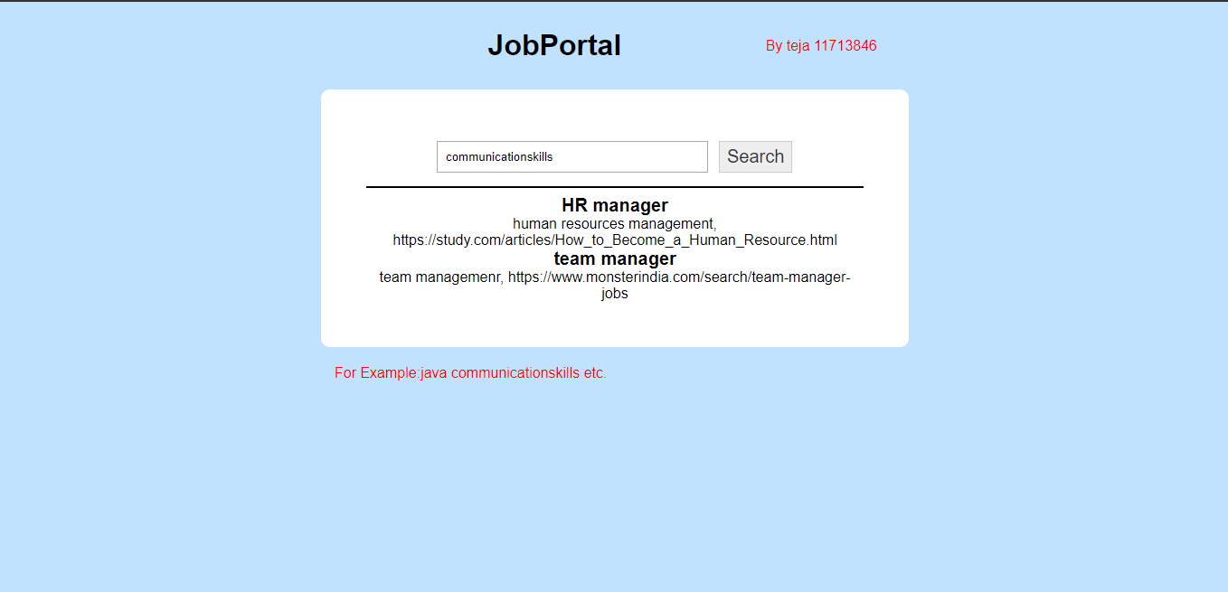

This screenshot is having a output of skill communication skill in the search engine